Welcome to the Field Studies Council (FSC)
Higher Education Student Placement
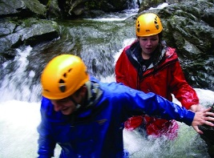
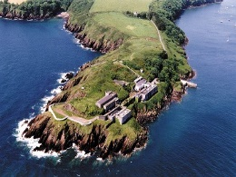
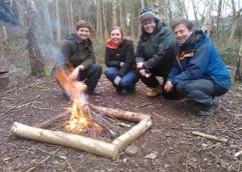
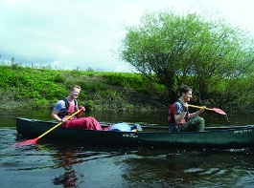
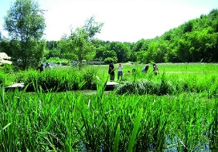

About Field Studies Council
Main business: Charity
Field Studies Council, FSC, is an environmental education charity providing informative and enjoyable opportunities for people of all ages and abilities to discover, explore, and understand the environment.
We are an independent charity receiving no core revenue funding from statutory sources and we therefore rely on fees paid by our visitors and on the generosity of donors, trust funds and grant bodies to finance our activities.

Placement Summary
We are looking for students who are enthusiastic about the environment and who want to develop their skills and understanding of a field centre. You will be a student who is committed to learning and development, eager to be involved in and understand the workings of the FSC. In turn we will support you and give you a valuable learning experience.

Being a HE Student Placement with the FSC is wide-reaching. For the right individual, time with us can offer an array of opportunities and enriched experiences. The individual tasks and focus may vary depending on which field centre you are based at and you will be able to gain valuable experience of living and working within a field centre setting. All of our learning locations are based within beautiful surroundings close to nature as this is the essence of what we do.

Unfortunately, we are not able to guarantee which centre you will be placed at until the appointment stage. Whatever the FSC location all HE Student Placements have the chance to work with education groups – some centres work with very young children, some centres have mainly secondary school groups, and others have university and adult courses.

Summary of Post
To be a Higher Education (HE) Student Placement with FSC you must be undertaking a UK-based higher education course where a placement is a requirement. We are looking for candidates studying towards a degree in Geography, Biology, Ecology, Environmental Science, Education or a closely allied discipline. The role is to primarily support our teaching staff in the delivery of field courses along with a range of other residential and domestic duties. To be successful you will want to work with people who are enthusiastic about the environment and keen to see that people are taught to understand and respect it better.

All placement students will:

- Support our Tutors in delivering outdoor learning
- Possess excellent interpersonal skills, initiative, and a proactive and flexible attitude, as evening and weekend duties will be required
- Practice essential work / life skills, multi-tasking, time management, prioritisation and resilience
- Carry out various duties such as:
  - Daily - weather monitoring, issuing waterproofs/wellies, preparing safety sacks, vehicle checks, cleaning classrooms and equipment
  - Weekly - maintaining field equipment
  - Monthly - checking first aid kits
- Become First Aid trained with an external qualification
- Be trained in essential areas including Risk Assessments, Water Safety, Child Protection, Manual Handling, Fire Safety and General Data Protection Regulations (GDPR)
- Attend a ‘Welcome to the FSC’ event to meet other HE Student Placements and set objectives to get the best out of the year
- Gain an overview of the Education Sector
- Be part of the essential 24-hour duty system to ensure FSC meet the needs of our customers, requiring HE Student Placements to undertake one overnight ‘sleep-in’ duty per week
- Work in the Learning Location shop and / or bar
- Have the opportunity to attend leisure learning courses at their location when there are available spaces
- Provided with shared staff accommodation with their own bedroom, as this is a live-in role

Contract Term:
This is a fixed-term appointment for a maximum of 12 months for students who are undertaking a UK-based Higher Education course where a placement is a requirement.

Remuneration:
As a student on a Higher Education course undertaking a placement with the Field Studies Council as part of your studies you are exempt from the National Minimum Wage (NMW) for up to a maximum of one year. Placements receive an Allowance of £89 per week payable monthly in arrears by credit transfer.

Location of post:
This post will be based according to business need at one of FSC’s Learning Locations in the UK participating in the HE Student Placement programme. Whilst candidates can request as part of their application their preferred FSC location this cannot be guaranteed and would not be confirmed until the appointment stage.

Accommodation:
Students will be provided with a single occupancy room. Some rooms may have an en-suite and others have shower and toilet facilities close by. Students will have access to a shared kitchen where they will be able to make their own meals.

Resident students will have a deduction of 20% taken from your allowance and you will be required to sign a residential accommodation agreement. Food will be provided during the course of your duties only, and will not be included on your days off and holidays. If you are resident at a day centre, food is not included.

Hours of work:
This post is based on a notional average of 37.5 working hours per week, this will equate to a total of 1950 hours of work annualised over a full year. The weekly hours are based on a flexible shift pattern, this will fluctuate throughout the year according to business needs which means that the post holder may be required to work more hours during busy periods and considerably less in other weeks to compensate. Evening, weekend and Bank Holiday working will be required. Placements at Residential Learning Locations are required to undertake one overnight ‘sleep-in’ duty per week as an integral part of the post; this will be in addition to your normal working hours stated above.

How to apply:
For the full vacancy pack and details of how to apply online please go to: https://fieldstudiescouncil.current-vacancies.com/Jobs/Advert/2475831?cid=2021&t=Higher-Education-Student-Placement

Within your application
You must ensure that your application includes examples of how you have demonstrated skills, knowledge and experience in meeting the requirements of the post detailed in both the job description and person specification.

Please also state what makes you the ideal candidate to be a Higher Education Student Placement with the FSC and what specific areas of your degree you want to develop during your placement year.

Want to find out more about Field Studies Council and our amazing locations then visit www.field-studies-council.org

The closing date for receipt of your completed application is 12 noon on Thursday 31 March 2022.

Interviews will take place on Thursday 28 April 2022 location to be confirmed.

Shortlisted applicants will be contacted by email.

Additional Information

Locations where Placements are likely to be available:

FSC Blencathra, Nr Keswick, Cumbria
FSC Castle Head – Grange-Over-Sands, Cumbria
FSC Epping Forest – High Beach, Loughton, Essex
FSC Juniper Hall – Dorking, Surrey
FSC Millport, Isle of Cumbrae, Scotland
FSC Nettlecombe Court, Taunton, Somerset
FSC Rhyd-y-creuau, Nr. Conwy, Snowdonia
FSC Preston Montford – Shrewsbury, Shropshire

Other centres may be available.
To view details about our learning locations please see - https://www.field-studies-council.org/centres/

Benefits:
Equality & diversity
Disability confident employer
Pension
Health Cash Plan
Employee Assistance Programme

Training and Development

Free Parking

Free Tea/Coffee

Discounts

https://www.ratemyplacement.co.uk/search?s=field%20studies%20council&show=reviews

